**Pushing a Docker Image to DockerHub by using Jenkins and adding a Tag of Build number to the Docker image**

**Step:1:-**

Open Instance and start the Jenkins server in that Instance.

**Step:2:-**

Open Jenkins

Click **NewItem** 🡺 Create Job by using Pipeline.

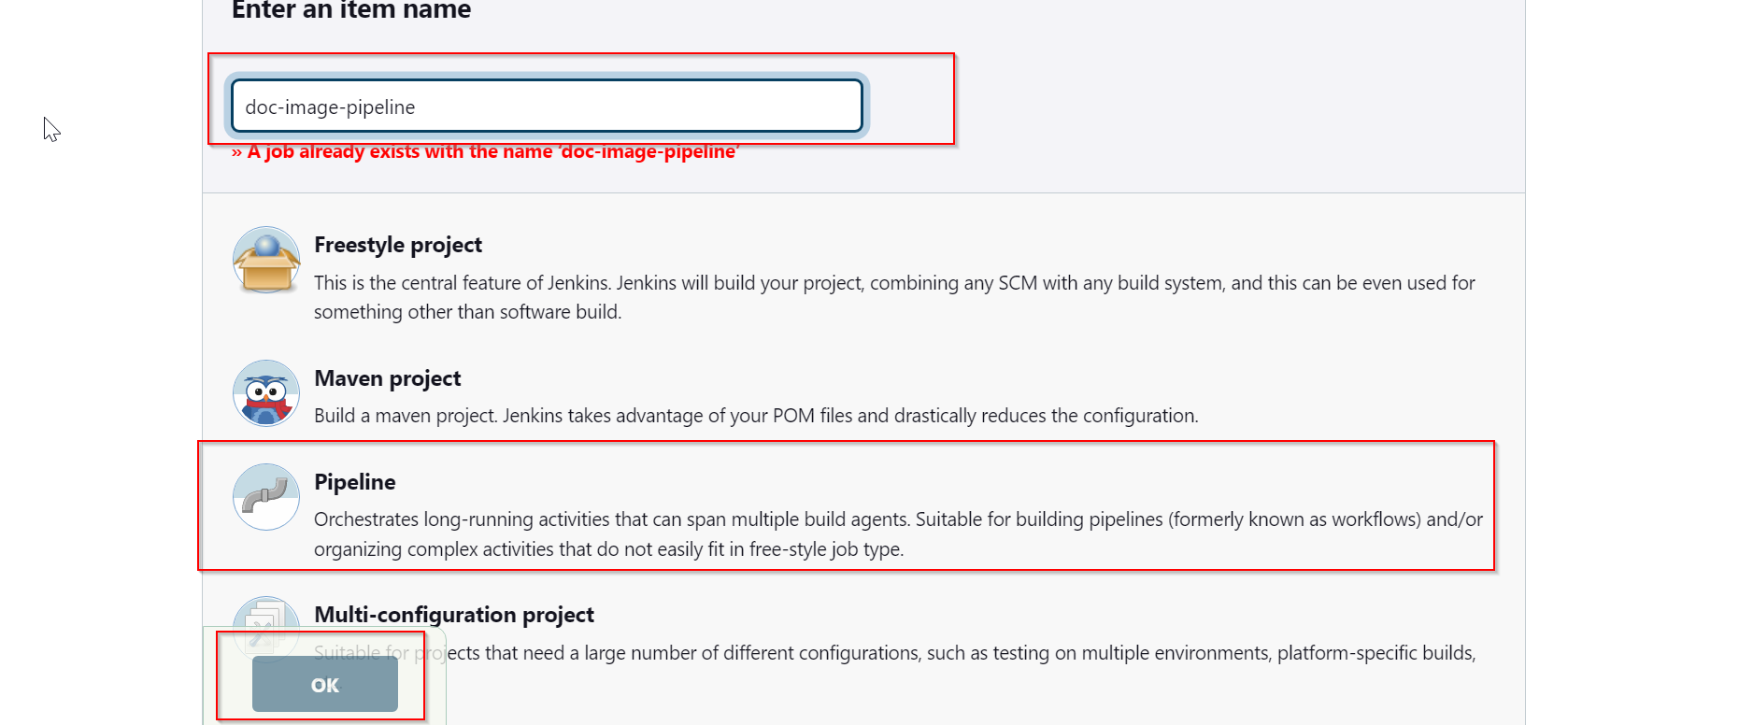

**Step:3:-**

First we add the Docker Hub Credentials in the Manage Credentials in Jenkins

Manage Jenkins 🡺 Manage Credentials 🡺 global 🡺 Add Credentials

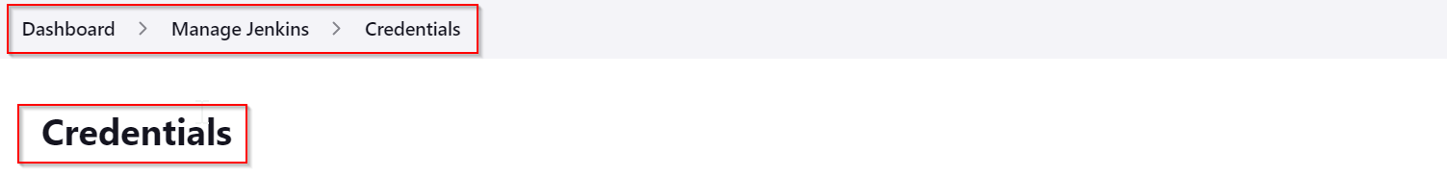

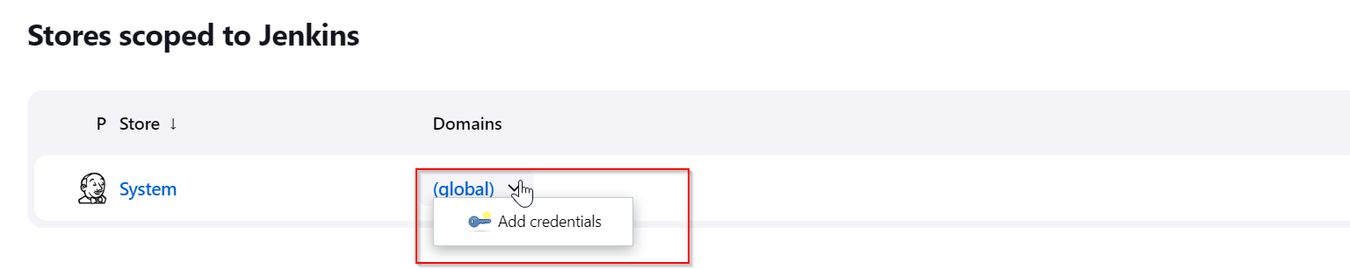

Creating the Credentials:

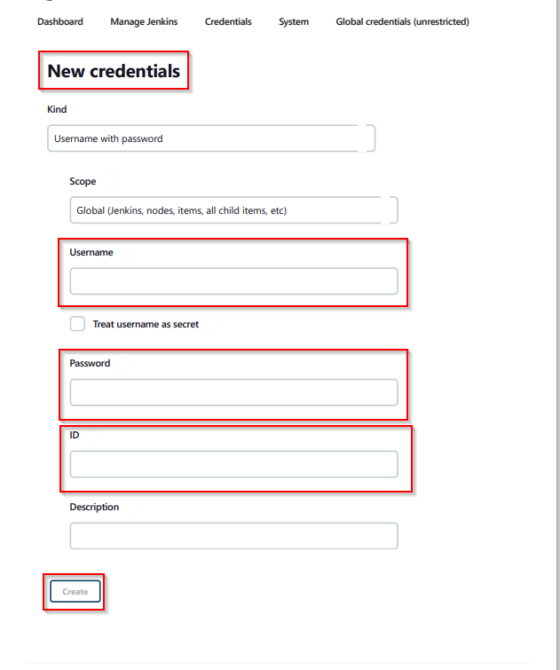

After we add the pipeline Script in Jenkins

Step:4:-

Open a Job write a Pipeline Script

// By adding the credentials of Dockerhub to push image on Dockerhub by using Jenkins Pipeline

pipeline {

    agent any

    tools {

        maven 'Maven'

    }

    environment {

        dockerhub=credentials('dockerhub')

    }

    stages {

        stage('git') {

            steps {

                git 'https://github.com/rkrcss/hello-world.git'

            }

        }

        stage('Build') {

            steps {

                sh 'mvn clean package'

            }

        }

        stage('docker') {

            steps {

                sh 'docker build -t krkr95/tom:${BUILD_NUMBER} .'

            }

        }

        stage('Push Image') {

            steps {

                sh 'echo $dockerhub_PSW | docker login -u $dockerhub_USR --password-stdin'

                sh 'docker push krkr95/tom:${BUILD_NUMBER}'

            }

        }

    }

}

🡺 Save the job.

**Step:5:-**

Build the Job

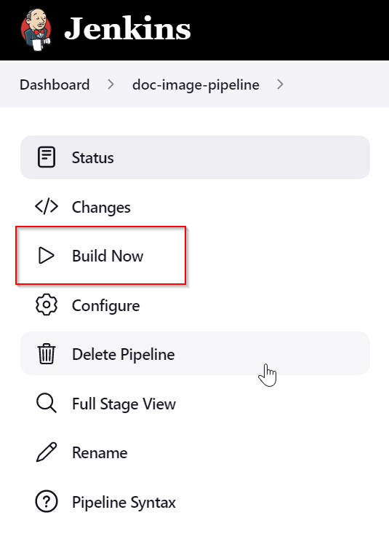

🡺 Go to your Pipeline project on Jenkins and click on **Build Now** to run manually. You should get a sequential output of the different stages similar to this one:

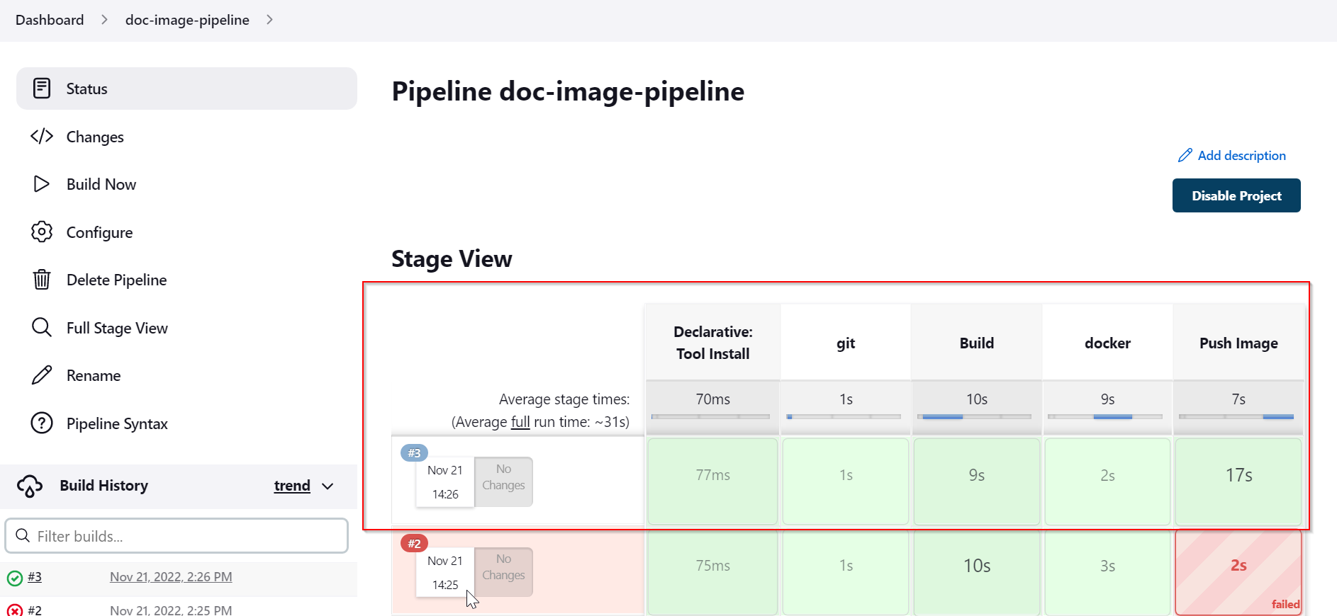

We can see Console Output.

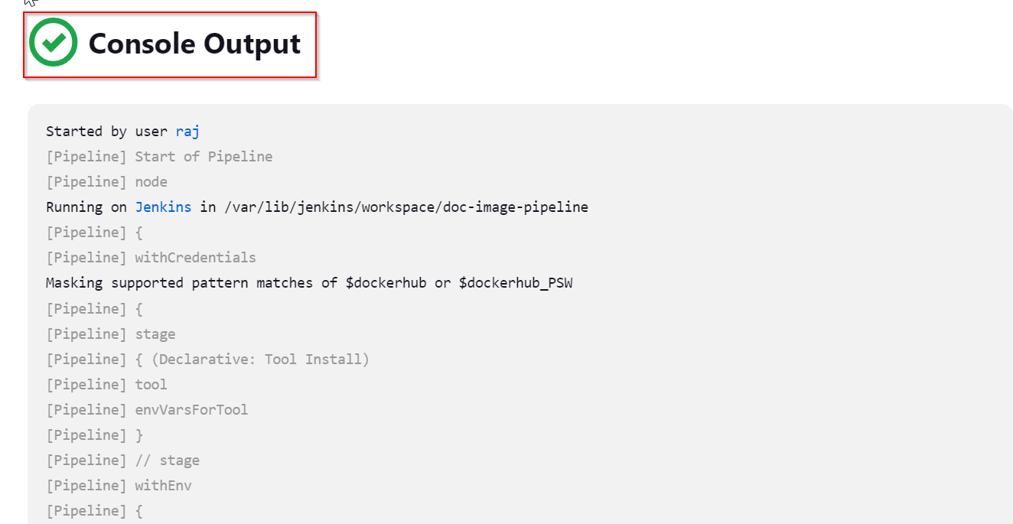

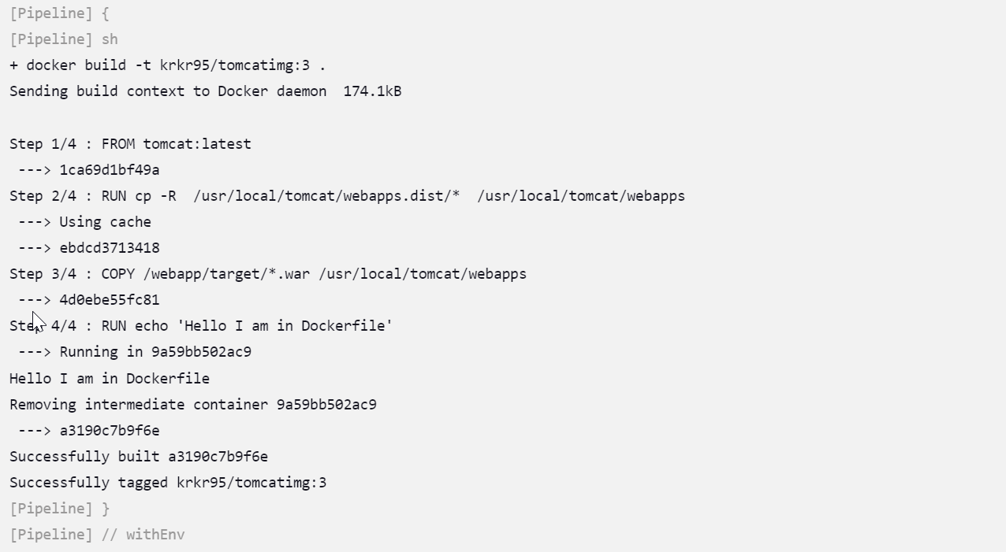

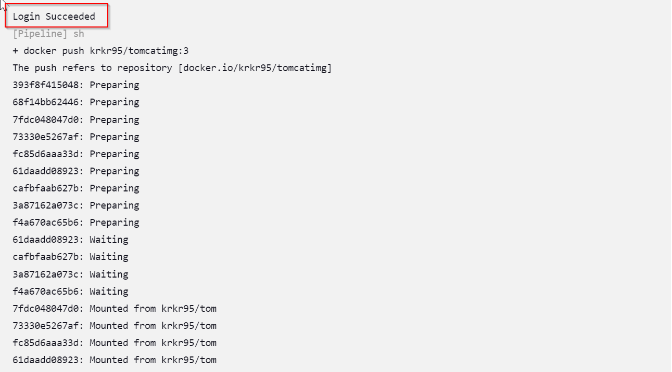

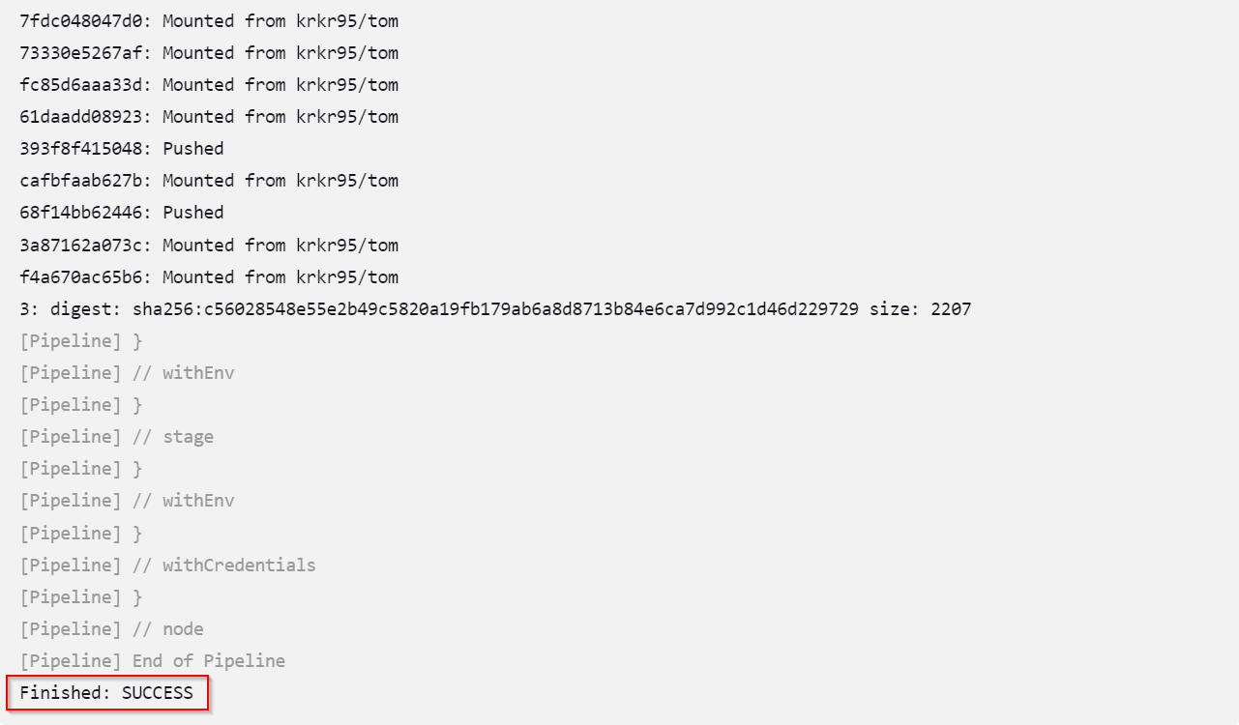

The pipeline run successfully. If it is not successful in the image red colour was shown that pipeline was failed.

**🡺 Build was Successful**

**The Docker Image pushed to Docker Hub by Jenkins Pipeline.**

For this we need to create the exact name in DockerHub that we mention in the Jenkins Pipeline on that time only the image will push to DockerHub

In the Docker Hub:

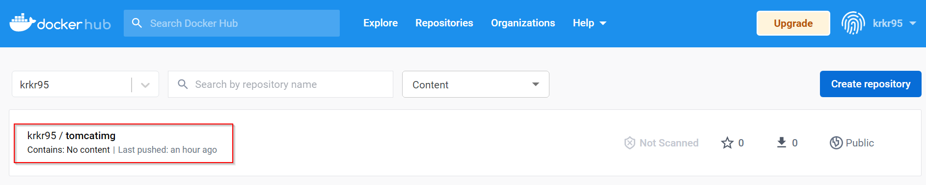

The Image is pushed by Jenkins Pipeline with The Build_Number of Job.

